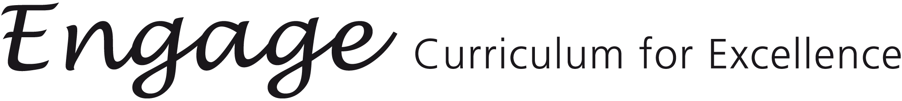
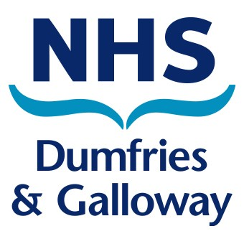
Frequently Asked Questions

1. Are schools expected to adopt the lesson plans as provided?

There is no expectation that schools will adopt some (or any) of the lesson plans. After all, many schools already work closely within clusters to address issues relating to Health and Wellbeing and have excellent materials in place to support their programmes of learning. What, however, would be expected is for schools to ensure that they have addressed the Outcomes and Experiences relating to Health and Wellbeing and are able to identify ways in which these outcomes are being achieved.

2. Have Education, Police and the NHS (School Nurses) worked together
on this project?

Very much so. In the area of Relationships, Sexual Health and Parenthood, there was a complete sharing between Education and the School Nurses of the way forward in the development of materials for use in the classroom. The work done on this Outcome was monitored at every stage by the Sexual Health Strategy Group which included representation from a range of practitioners from sexual health and education.

The Police have developed, for their officers working in schools, a range of lesson plans relating to Substance Misuse, Anti-Social Behaviour, Personal Safety and Road Safety. These plans have also been framed within the Health and Wellbeing Outcomes and fully complement work done on the same outcomes within education. In other words - there is uniformity and coherence in the work completed by both partner agencies.

3. Should our school be aware of the work being done to address
outcomes in other sectors?

Definitely. Transitional arrangements already ensure progress and continuity of learning in key areas; this should include Health and Wellbeing.

4. What if our school has not got access to some of the resources
suggested in the lesson outlines?

Given the number of schools within our Authority it is impossible to identify resources which every school currently uses. Seconded staff working on the materials visited schools to identify key resources commonly used whilst, at the same time, ensuring that materials suggested addressed outcomes. Inevitably, this means compromising between what schools currently use and what is coming on to the market. Wherever possible, ICT resources have been included, though not exclusively, as pupils learn in different ways and a variety of approaches and methodologies is desirable.

5. Were those working on the lesson plans familiar with how teachers
operate in schools?

All seconded staff were practising teachers from different sectors and with a wide range of teaching experience. All have now returned to the classroom. We also took advice from a range of school practitioners and other professionals (notably from NHS and the Police) to support us.

6. How about ‘timings’ for lessons?

Where possible, estimated times for different activities have been given though, clearly, schools allocate different periods of time to lessons relating to health and wellbeing and a ‘one-size-fits-all’ formula is not possible. A primary school may, for example, spend an afternoon on a particular Health and Wellbeing activity. Secondary schools allocate different lengths of time to, for example, PSE classes – from 20 minute slots upwards. Forward planning and familiarity with materials and resources is required to ensure a well structured provision of learning experiences.

7. Can we use the templates to create our own programmes of work?

Yes - and this is to be encouraged. It is possible to retain the original documents whilst working on copies to produce plans to suit individual schools. In other words, schools may wish to revise suggested developments and resources to reflect work being done in their own locations. The key points to consider are:

a) acknowledgement of the Experiences and Outcomes
b) close partnership working
c) planning which includes partners in advance of the new school session

8. How fixed are the ‘age and stage’ suggestions in the lesson plans?

The ‘age and stage’ suggestions are in no way prescriptive as practitioners must always be sensitive to the needs and capacities of their own pupils; they alone are best able to decide which lessons are appropriate for which pupils within their own particular classroom context.

9. What about values and attitudes? Are they not fundamental to all
teaching and learning?
The lesson plans and support materials have been constructed within the framework of the following overarching principles:

- Values and attitudes
- Self-awareness
- Awareness of others
- Respect and responsibility
- Personal and social skills
- Knowledge and understanding

These elements of the young person’s personal growth and development are embedded within the Health and Wellbeing learning outcomes and experiences as well as being implicit within the 4 Outcomes for Scottish education. They will be reflected across all areas of school life and, consequently, they can be identified, recorded and reported upon as part of a systematic review and monitoring of pupil progress.

10. Who should deliver the Health and Wellbeing Outcomes?

Everybody! All members of the school community and beyond (parents, carers, partner agencies) have a joint responsibility for the welfare of our children and young people.

Within all sectors, learning outcomes can be achieved through a range of subjects, experiences and activities. In the secondary sector this means that PSE classes should no longer be regarded as the sole repository for health and wellbeing issues; they should span the whole curriculum, both during and outside school hours. Imaginative and creative ways of promoting this agenda are to be encouraged.

11. How can our school evaluate and measure attainment and achievement in this area of work?

Another way of putting this question might be to ask how the 4 purposes can be assessed:

Successful Learners
Confident Individuals
Effective Contributors
Responsible Citizens

The key document in this regard is the Journey to Excellence which ‘reports some of the things which young people, teachers, head teachers,
parents, support staff and other members of the school community have
told us they are doing to achieve excellence.’ This document provides schools with the framework within which to create a culture of achievement, success and excellence in all areas of school life. Health and wellbeing plays a significant role in this vision for schools as a community of learners.

As practitioners know, it is personal and social development which is central to progress in the area of health and wellbeing; assessment of this dimension of a pupil’s progress is not subject to numerical or statistical analysis and, therefore, alternative modes of assessment need to be deployed which can identify the overarching principles (as highlighted above) which frame these lesson outlines and supporting materials.

